# CS 340 README Template

## About the Project/Project Title

*This project was intended to be a dashboard for Grazioso Salvare to review and filter through animals at the Austin Animal Shelter. The project uses a create, read, update, and delete python file to make changes to the roster of animals at the shelter.*

## Motivation

*My motivation for completing this project is to continue to build on my skills of building, interacting, and controlling a database and utilizing different tools to show and manipulate the data.*

## Getting Started

*Over the last several weeks, I have been preparing for the final steps of this project.*

*I began by importing the database csv file into MongoDB.*

*I then created a user for the database that had read and write permissions.*

*A Python file was created that allows a user to create, read, update, and delete entries.*

*Gaining access to the database through the CRUD.py file is important to the final project.*

*Through Jupyter Notebook, I created an ipynb file that sends the user to a dashboard.*

*On the dashboard, the data is presented in a couple of different ways.*

*The dashboard has a table that represents the data in rows and columns.*

*The user can filter through the data by selecting individual rows or columns and typing in specific elements.*

*There are also radio buttons to provide Grazioso the ability to select breeds based on their predetermined list of breeds by parameter.*

*Below the table are two more tools to help analyze the data. 1. Pie chart to see what makes up the contents of a filter. 2. An interactive map to show you where a selected animal is located.*

## Installation

*This project was built with a few separate tools including MongoDB, Python, and Jupyter Notebook. You will need to have information to gain access to the MongoDB including the correct username and password, a current version of Python, and a current version of Jupyter notebook or something that can run a test file.*

**Functionality and Rationale**

*Mongodb was chosen for this project because it is known for its flexibility and scalability. It’s primarily used when dealing with large amounts of unstructured data. It is a database that works with documents to allow for easy storage and retrieval of data. PyMongo is the driver that allows a relationship between MongoDB and Python. PyMongo’s qualities are simplified API, BSON and JSON support, indexing, querying, and filtering. It provides a simple yet feature happy interface for developers building applications that use both sets of technology. Dash uses syntax that is clearly laid out in the Python code. It allows developers to show the structure of the application and its behavior in one place. Dash applications are built using components that are reusable by promoting modularity and simplifying the development process. The callback system define the relationship between user inputs and outputs. This connects the controller logic with the view and makes it more intuitive for developers.*

**Product Details**

*Since Grazioso is asking for this program to be created, they also have a few requirements that I have mentioned previously, and I will now share the details. The first line of business for them is to present their personalized logo on the site. They would like the photo to also act as a pathway back to their website(www.snhu.edu). They want a data table that has custom filters including water rescue, mountain or wilderness rescue, and disaster rescue or individual tracker. They want a pie chart that shows a graph of the available breeds, and they also would like a map with the location of the animal that has been selected from the data table.*

## Usage

*Below is a screenshot that shows the main landing page for the Animal Shelter. As you can see, the Grazioso logo is in the center of the screen. The icon can be selected to send you to the website intended, below that is the data table with specified radio buttons to filter for the 3 groups previously noted, pie graph, and interactive map.*

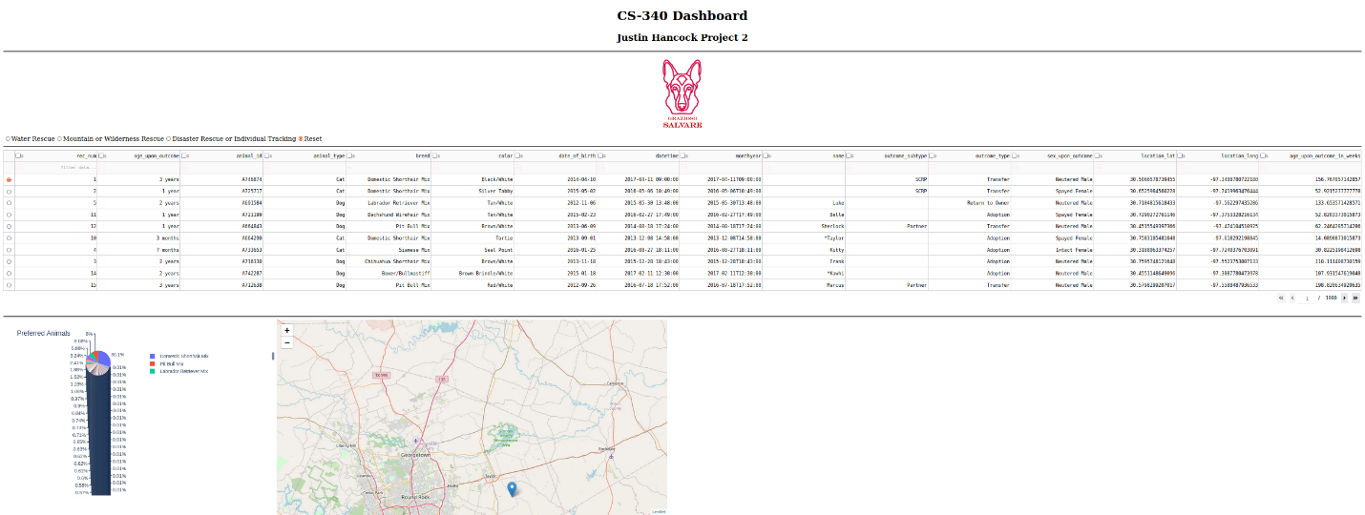

*Interactive map showing a selected animal’s current location.*

*Below shows the pie chart filtered by the mountain or wilderness rescue dogs.*

*Below is the pie chart filtered by the disaster rescue or individual tracker dogs.*

## Challenges

*I was able to get my filter to work for all filters but the water rescue filter. I get an error code that tells me “_id” is not a valid item on the axis. I tried testing to figure out what the issue is, but I was unable to get it to work properly.*

## Contact

Your name: Justin Hancock